2015 ISES Accompanying Person Tour Reservation.
*Please type or print clearly.
Welcome to Daegu

City of Daegu and Daegu Convention & Visitors Bureau offer 3 benefits (Free guide, Free Transportation, Safe Tour ) available only for SWC 2015 Accompanying Person.
If you would like to receive these benefits when you visit Daegu, Please complete this form and send to SWC Organizing Committee. (accommodation@swc2015.org)
Also, If you would like to go on the tour schedule as we suggested under the table, please write your opinion in Requirement.

◆ Participant Personal Information
First Name: | Last Name: (□ Mr. □Ms.)
Country: | Age:
Address:
Phone: | E-mail:

◆ Accompanying Person Personal Information (1)
First Name: | Last Name: (□ Mr. □Ms.)
Country: | Age:
Address:
Phone: | E-mail:

◆ Accompanying Person Personal Information (2)
First Name: | Last Name: (□ Mr. □Ms.)
Country: | Age:
Address:
Phone: | E-mail:

◆ Requirement

◆ Examples of Tour Program

Example 1 : Mt. Palgongsan Tour
■ Guide |  |  | English speaking guide
■ Included |  |  | transportation, tour guide
Day |  | Trans. | Detail | Meals
 |  | BUS | ‣ 13:00 Departing EXCO / Hotel  ‣ 13:30 Daegu Bangjja Yugi(Korean Bronzeware) Museum  Bangjja is a vessel made by pounding melted  brass. Bangjja Yugi Museum is the nation's  only brassware-specialized museum.  Quality brassware made by brassware  specialist Lee Bong-ju is on display.  ‣ 15:00 Donghwasa Temple  Time-honored Buddhist temple, built in 493. On the premises of the temple, a main worshipping hall (Dawoongjeon) and an enormous statue of a Stone Buddha (Tongil-yaksa-yeoraedaebul) standing up high are available for followers of Buddhism.  ‣ 17:00 Bullo-dong Ancient Tomb Park  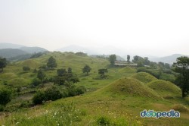  The Bullo-dong is adjacent to Geumho-gang  (Geumho River), and the ancient tomb cluster  is located in the east hill met by the road from  Bullo-dong to Palgong Mountain as well as  Gyeongbuk expressway. There are totally 211  ancient tombs in different sizes clustered here.  ‣18:00 Arrival at EXCO or Hotel | No  Meal

◆ Examples of Tour Program

Example 2: Daegu City Tour
■ Guide |  |  | English speaking guide
■ Included |  |  | transportation, tour guide
Day |  | Trans. | Detail | Meals
 |  | BUS | ‣13:00 Departing EXCO or Hotel  ‣13:30 Dongseongno Street & Kim Kwang-seok Road  A downtown street square full of youth Dongseongno refers to the 900m-long section between the Daegu Station intersection and the Jungang Community Policing Station. It is one of the representative downtown areas of Daegu. Originally it was the site of a fortress west of the Daegu townwall, but it was demolished in 1907  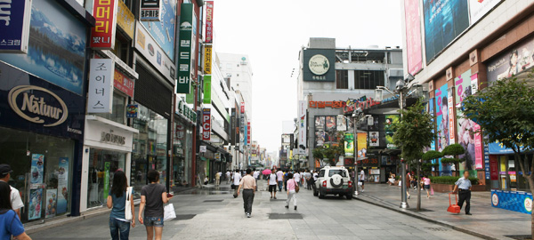  This is one of the most popular tours in Daegu. Participants can experience the modern cultural aspects of Daegu through sightseeing of buildings constructed in the modern period, old houses of nationalist fighters and so on. Anyone interested can participate and it is a free tour.  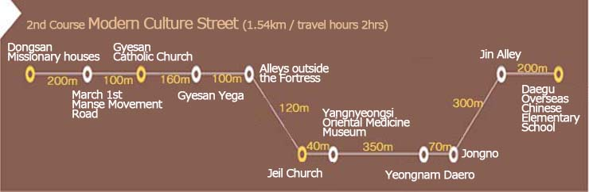  ‣ 15:00 Yangnyeongsi Museum of Oriental Medicine  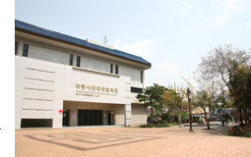  Yangnyeongsi Museum of Oriental Medicine is such an interesting place to learn about oriental medicine and get helpful information for your health. If you legs and feet are tired enjoy a foot bath in the front yard of the museum.  ‣ Experience of Oriental Medicine ( Fee.\5,000 / Not included)  Making oriental natural air freshener  Use 7 fragrant herbal ingredients to make an oriental natural air freshener  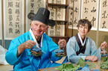  ‣ 18:00 Arrival at EXCO or Hotel | No  meal

